CHAPTER 1
INTRODUCTION

This chapter includes the Title, Problem Statement and brief introduction about Hardware realization of variable frequency and duty cycle generator.It also includes the system schematic diagram, specifications and Platform used for this project.
1.1 TITLE
Hardware realization of variable frequency and duty cycle generator.
1.2 PROBLEM STATEMENT
To design and develop variable frequency and duty cycle generator, synthesis and
simulate the result.
1.3 INTRODUCTION
A frequency synthesizer is a circuit design that generates a new frequency from a single stable reference frequency. Mostly a crystal oscillator is used for the reference frequency. Most of the frequency synthesizers employ a Phase Locked Loops circuit, as this technique over many advantages such as minimum complex architecture, low power consumption and a maximum use of Large Scale Integration technology. There are many designs in communication that require frequency synthesizer to generate a range of frequencies; such as cordless telephones, mobile radios and other wireless products. The accuracy of the required frequencies is very important in these designs as the performance is based on this parameter. One approach to this necessity could be to use crystal oscillators. It is not only impractical, but is impossible to use an array of crystal oscillators for multiple frequencies. Phase Locked Loop technique in frequency synthesizer is that it can generate frequencies comparable to the accuracy of a crystal oscillator and offer other advantages such as minimum complex architecture, low power consumption and a maximum use of Large Scale Integration technology. Therefore some other techniques must be used to circumvent the problem. We will attempt to generate this frequency using a FPGA and compensate for the unwonted and unwanted irregularities. The main benefit of using FPGA technique in frequency synthesizer is that it can generate frequencies comparable to the accuracy of a crystal oscillator and over other advantages mentioned previously. The benefit of using a FPGA is that the coding can be done in VHDL and the output can be varied according to observations. This will not only increase the transparency of the result but also help faster checking and correction of the results. FPGA also allows us to generate many multiples and divisors of the required frequency

1.4 SYSTEM SCHEMATIC DIAGRAM
The system schematic diagram of proposed system is shown in Fig1.1,
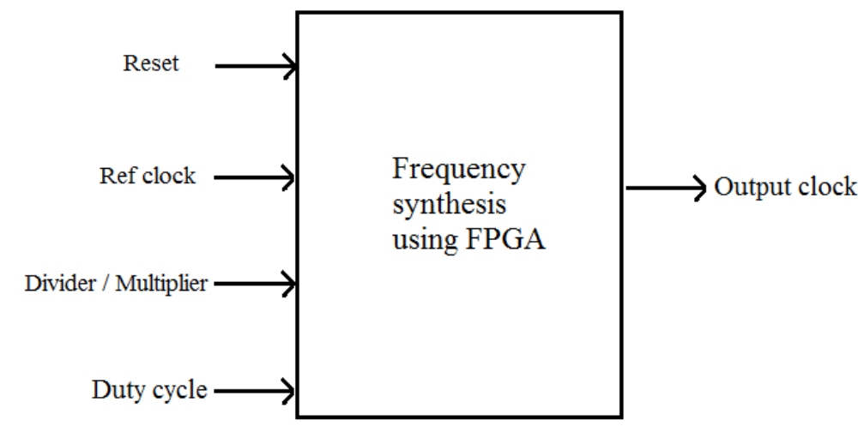
Fig1.1 System Schematic Diagram

1.5 SPECIFICATIONS
a. Clock source frequency: - 1MHz
b. Output frequency range: -
c. Duty cycle range: - 10% to 80%
d. Division factor range: -
e. Multiplication factor range: -
1.6 PLATFORM USED: The Hardware and Software platform used are as given below:

1.6.1 HARDWARE:
Xilinx Spartan 3E-250 planted in Basys board.

1.6.2 SOFTWARE
Xilinx 11.1 logic edition
ModelSim SE 6.3f

CHAPTER 2
LITERATURE SURVEY

This chapter includes the existing technique of frequency synthesis which includes DCM , DLL, Direct digital synthesis.
It also includes the Proposed System and Algorithm for that.

2.1 EXISTING TECHNIQUE OF FREQUENCY SYSTHESIS

Several different frequency synthesis techniques have been presented in the literature over the years. They can be quite clearly divided into three separate categories, namely direct analog synthesis, direct digital synthesis, and indirect analog synthesis [2,3 and 4]. In this context, “indirect” refers to a system based on some kind of a feedback action, whereas “direct” refers to a system having no feedback. Some of the inbuilt frequency synthesis techniques in FPGA are DCM and DLL.

2.1.1 DCM (DIGITAL CLOCK MANAGER)

Spartan-3 devices provide flexible, complete control over clock frequency, phase shift and
skew through the use of the DCM feature [1]. To accomplish this, the DCM employs a DLL, a fully digital control system that uses feedback to maintain clock signal characteristics with a high degree of precision despite normal variations in operating temperature & voltage. Each c component has its associated signals, as shown in Fig 2.1.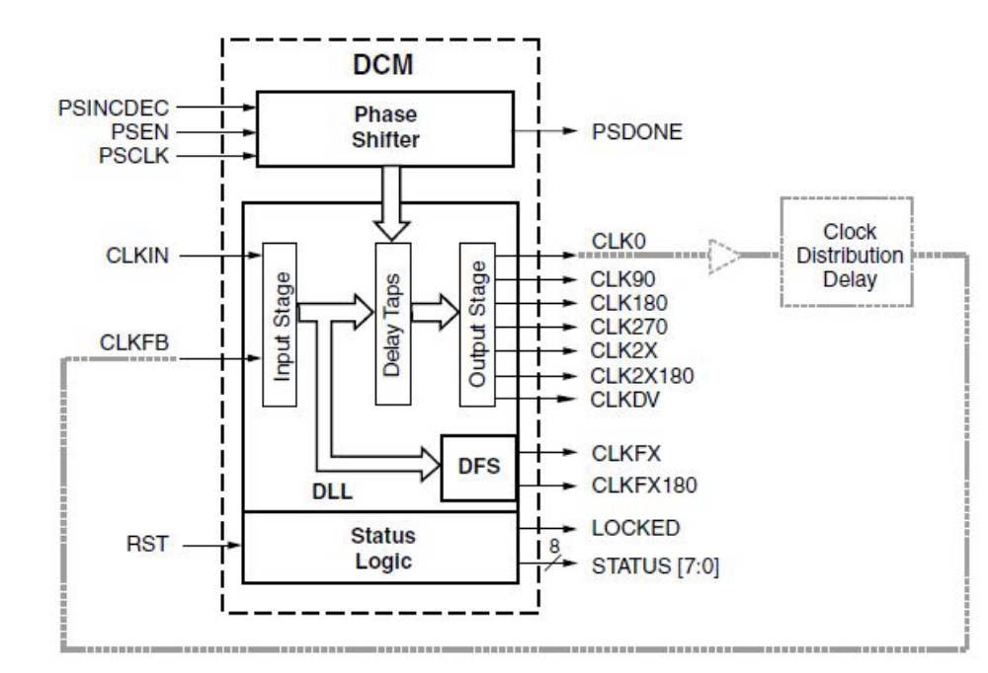.
The DCM supports three major functions:
i) Clock-skew Elimination: Clock skew describes the extent to which clock signals may, under normal circumstances, deviate from zero-phase alignment. It occurs when slight differences in path delays cause the clock signal to arrive at different points on the die at different times. This clock skew can increase set-up and hold time requirements as well as clock-to-out time, which may be undesirable in applications operating at a high frequency,
when timing is critical. The DCM eliminates clock skew by aligning the output clock signal it generates with another version of the clock signal that is fed back. As a result, the two clock signals establish a zero-phase relationship. This effectively cancels out clock distribution delays that may lie in the signal path leading from the clock output of the DCM to its feedback input
.
ii) Frequency Synthesis: Provided with an input clock signal, the DCM can generate a wide range of different output clock frequencies. This is accomplished by either multiplying and/or dividing the frequency of the input clock signal by any of several different factors.

iii) Phase Shifting: The DCM provides the ability to shift the phase of all its output clock signals with respect to its input clock signal. The DCM has four functional components: the Delay-Locked Loop (DLL), the Digital Frequency Synthesizer (DFS), the Phase Shifter (PS), and the Status Logic.

2.1.2 DLL (DELAY LOCK LOOP)

The most basic function of the DLL component is to eliminate clock skew [1]. The main signal path of the DLL consists of an input stage, followed by a series of discrete delay elements or taps, which in turn leads to an output stage. This path together with logic for phase detection and control forms a system complete with feedback as shown in Figure 20. The DLL component has two clock inputs, CLKIN and CLKFB, as well as seven clock outputs, CLK0, CLK90, CLK180, CLK270, CLK2X, CLK2X180, and CLKDV as shown in Fig 2.2. The clock outputs drive simultaneously; however, the High Frequency mode only supports a subset of the outputs available in the Low Frequency mode. See DLL Frequency Modes. Signals that initialize and report the state of the DLL are discussed in The Status Logic Component. The schemaic block diagram of DLL is shown in Fig 2.2.
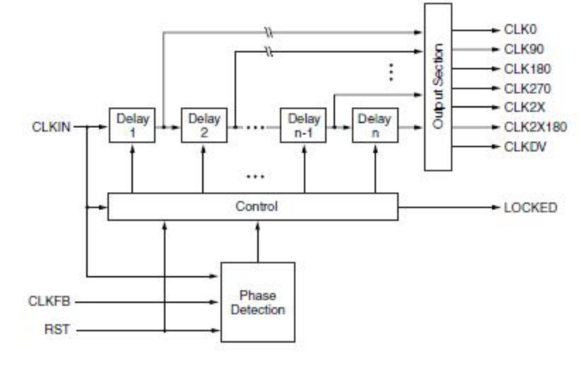
Fig2.2. DLL block diagram [1]
DLL Signals
The clock signal supplied to the CLKIN input serves as a reference waveform, with which the DLL seeks to align the feedback signal at the CLKFB input. When eliminating clock skew, the common approach to using the DLL is as follows:

Table2.1. DLL Signals [1]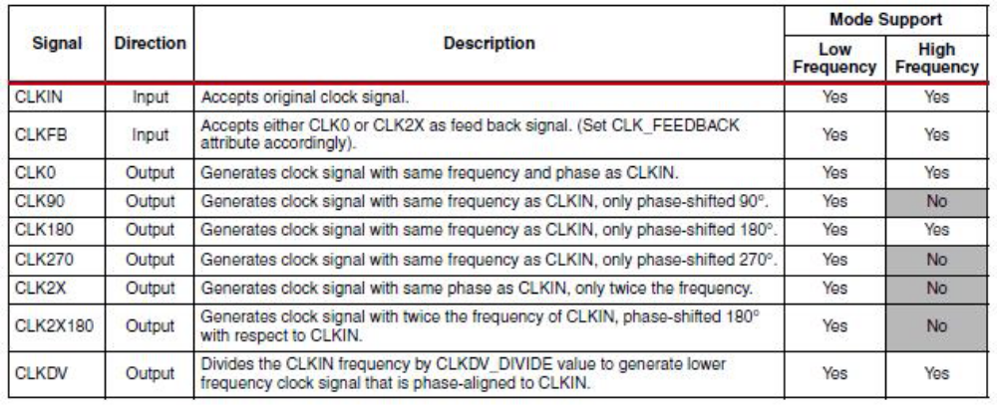
The CLK0 signal is passed through the clock distribution network to all the registers it synchronizes. These registers are either internal or external to the FPGA. After passing through the clock distribution network, the clock signal returns to the DLL via a feedback line called CLKFB. The control block inside the DLL measures the phase error between CLKFB and CLKIN. This phase error is a measure of the clock skew that the clock distribution network introduces. The control block activates the appropriate number of delay elements to cancel out the clock skew. Once the DLL has brought the CLK0 signal in phase with the CLKIN signal, it asserts the LOCKED output, indicating a “lock” on to the CLKIN signal
.
DLL Attributes and Related Functions

A number of different functional options can be set for the DLL component through the use of the attributes described in Table2.2 Each attribute is described in detail in the sections that follow:
Table2.2 DLL Attributes [1]
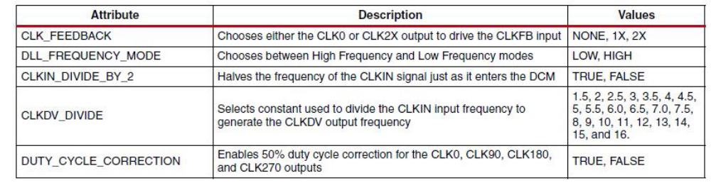
DLL Frequency Modes

The DLL supports two distinct operating modes, High Frequency and Low Frequency, with each specified over a different clock frequency range. DLL_FREQUENCY_MODE attribute chooses between the two modes. When the attribute is set to LOW, the Low Frequency mode permits all seven DLL clock outputs to operate over a low-to-moderate frequency range. When the attribute is set to HIGH, the High Frequency mode allows the CLK0, CLK180 and CLKDV outputs to operate at the highest possible frequencies. The remaining DLL clock outputs are not available for use in High Frequency mode
.
Accommodating High Input Frequencies

If the frequency of the CLKIN signal is high such that it exceeds the maximum permitted, divide it down to an acceptable value using the CLKIN_DIVIDE_BY_2 attribute. When this attribute is set to TRUE, the CLKIN frequency is divided by a factor of two just as it enters the DCM.

Coarse Phase Shift Outputs of the DLL Component

In addition to CLK0 for zero-phase alignment to the CLKIN signal, the DLL also provides the CLK90, CLK180 and CLK270outputs for 90°, 180° and 270° phase-shifted signals, respectively. These signals are described in Table 16, page 33. Their relative timing in the Low Frequency Mode is shown in Figure 22, page 37. The CLK90, CLK180 and CLK270 outputs are not available when operating in the High Frequency mode. For control in finer increments than 90°, see Phase Shifter (PS).

Basic Frequency Synthesis Outputs of the DLL Component

The DLL component provides basic options for frequency multiplication and division in addition to the more flexible synthesis capability of the DFS component, described in a later section. These operations result in output clock signals with frequencies that are either a fraction (for division) or a multiple (for multiplication) of the incoming clock frequency. The CLK2X output produces an in-phase signal that is twice the frequency of CLKIN. The CLK2X180 output also doubles the frequency, but is 180° out-of-phase with respect to CLKIN. The CLKDIV output generates a clock frequency that is predetermined fraction of the CLKIN frequency. The CLKDV_DIVIDE attribute determines the factor used to divide the CLKIN frequency. The attribute can be set to various values as described in Table 17. The basic frequency synthesis outputs are described in Table 16. Their relative timing in the Low Frequency Mode is shown in Figure 22. The CLK2X and CLK2X180 outputs are not available when operating in the High Frequency mode

Duty Cycle Correction of DLL Clock Outputs

The CLK2X(1), CLK2X180, and CLKDV(2) output signals ordinarily exhibit a 50% duty cycle even if the incoming CLKIN signal has a different duty cycle. A 50% duty cycle means that the High and Low times of each clock cycle are equal. The DUTY_CYCLE_CORRECTION attribute determines whether or not duty cyclecorrection is applied to the CLK0, CLK90, CLK180 and CLK270 outputs. If DUTY_CYCLE_CORRECTION is set to TRUE, then the duty cycle of these four outputs is corrected to 50%. If DUTY_CYCLE_CORRECTION is set to FALSE, then these outputs exhibit the same duty cycle as the CLKIN signal.

2.1.3 Direct digital synthesis
Figure 3.2 shows the basic principle of direct digital synthesis [3]. The desired output frequency is fed to the phase accumulator as a digital word. The phase accumulator increments its output value by this word once every clock cycle. When the full scale of the accumulator is reached, it wraps around. The output of the phase accumulator is thus a digital ramp signal, whose period is the same as that of the desired output frequency. In other words, the phase accumulator output contains information about the instantaneous phase of the synthesized frequency.The amplitude of a sinusoidal signal at different phase values is stored in the sine read-only memory (ROM). The instantaneous phase of the desired output signal is used as the address to the ROM, and the output is instantaneous amplitude of the synthesized signal[9,10]

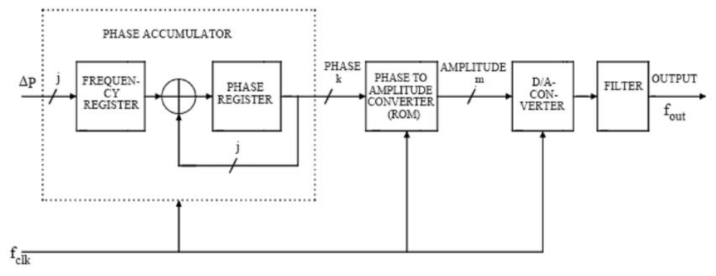
Fig2.4. Block diagram of Direct Digital Synthesizer [3]
To get an analog output signal, the amplitude information has to be converted to the analog domain in the digital-to-analog converter (DAC). The output of the DAC contains a lot of spurious tones, harmonics, etc., that have to be filtered out before the signal can be used. The smoothing filter in the output of the DAC attenuates the harmonics to an acceptable level, but the in-band spurious tones still remain. Their frequencies are predictable, but as they are in the signal band, they will not be attenuated by the filter. Direct digital synthesis has some very strong advantages. It has arbitrarily fine frequency resolution and a very high switching speed. Also, different phase, frequency, and amplitude modulations can be implemented in the digital domain, and require only a small amount of extra hardware. Due to the fact that most of the signal processing is done in the digital domain, direct digital synthesis also lends itself very well to full integration in a CMOS or BiCMOS technology. Until recently, the main disadvantage of direct digital synthesis has been the speed requirement and the huge power dissipation in the digital parts of the circuit, i.e. the phase accumulator and the sine ROM. However, with modern deep submicron CMOS technologies, the power dissipation has been dramatically reduced, and the achievable speed has become fairly high. Now, the bottleneck in the direct digital synthesizer is the DAC. Demands on the DAC clock frequency, resolution, and linearity are overwhelming.

2.2THE PROPOSED SYSTEM
The study part of the system includes the detailed literature of system software and hardware platform such as in our project we are using Spartan 3 FPGA as hardware platform and VHDL as a programing language.

2.2.1 ALGORITHM

1. Start
2. Get desired frequency or frequency divider factor.
3. Calculate the maxcount a given be with the formula
4. max_count = ref_clk*(1/Desired frequency)
5. The counter is incremented on every rising edge of the input clock (ref_clk) and the
counter is reset to ZERO when the terminal count of counter reaches to max_count
6. output clock: clkout (of desired frequency) is generated.
7. vary the duty cycle of clkout with the formula given below
8. count = (ref_clk/clkout)*(100-Duty)/100
9. The counter is incremented on every rising edge of the input clock (ref_clk) and the
counter is reset to ZERO when the terminal count of counter reaches to count
10. Final output clock: clkout (of desired frequency and duty cycle) is generated.
11. Jump back to step 2.

2.2.2 VHDL (Very High Speed Integrated circuit Hardware description language)

Hardware description languages (HDLs) are used to describe the architecture and behavior of discrete electronic systems. HDLs were developed to deal with increasingly complex designs. An analogy is often made to the development of software description languages, from machine code (transistors and solder), to assembly language (netlists), to high-level languages (HDLs). Top-down, HDL-based system design is most useful in large projects, where several designers or teams of designers are working concurrently. HDLs provide structured development. After major architectural decisions have been made, and major components and their connections have been identified, work can proceed independently on subprojects [5].

Advantages of Using HDLs to Design FPGAs:

Using HDLs to design high-density FPGAs is advantageous for the following reasons [6].

i)Top-Down Approach for Large Projects—HDLs are used to create complex designs. The top-down approach to system design supported by HDLs is advantageous for large projects that require many designers working together. After the overall design plan is determined, designers can work independently on separate sections of the code.

ii) Functional Simulation Early in the Design Flow—the functionality of design can be verified early in the design flow by simulating the HDL description. Testing the design decisions before the design is implemented at the RTL or gate level allows to make any necessary changes early in the design process.

iii) Synthesis of HDL Code to Gates—synthesizing the hardware description to a design implemented with gates. This step decreases design time by eliminating the need to define every gate. Synthesis to gates also reduces the number of errors that can occur during a manual translation of a hardware description to a schematic design. Additionally, application of the automation techniques used by the synthesis tool (such as machine encoding styles or automatic I/O insertion) during the optimization of your design to the original HDL code, resulting in greater efficiency
.
iv) Early Testing of Various Design Implementations—HDLs allow to test different implementations of design early in the design flow. The synthesis tool can be used to perform the logic synthesis and optimization into gates. Additionally, Xilinx® FPGAs allow to implement the design at computer. Since the synthesis time is short, designer has time to explore different architectural possibilities at the Register Transfer Level (RTL). Designer can reprogram Xilinx® FPGAs to test several implementations of design.

v)Reuse of RTL Code —Designer can retarget RTL code to new FPGA architectures with a minimum of recoding
.
VHDL Terms
A process is the basic unit of execution in VHDL. All operations that are performed in a simulation of a VHDL description are broken into single or multiple processes, which are as follows.

Sequential Statements:

The different types of sequential statements are as follows:
a. if Statements
b. case Statements
c. loop Statements

if Statements

The if statement executes a sequence of statements. The sequence depends on the value of one or more conditions. The syntax is
if condition then
[ { sequential_statement }
elsif condition then ]
{ sequential_statement }
[ else
{ sequential_statement } ]
end if;
Each condition must be a Boolean expression. Each branch of an if statement can have one or more sequential_statements.

case Statements
The case statement executes one of several sequences of statements, depending on the
value of a single expression. The syntax is case expression is
when choices =>
{ sequential_statement }
{ when choices =>
{ sequential_statement } }
end case;

loop Statements

A loop statement repeatedly executes a sequence of statements. The syntax is
[label :] [iteration_scheme] loop
{ sequential_statement }
{ next [ label ] [ when condition ] ; }
{ exit [ label ] [ when condition ] ; }
end loop [label];

for...loop Statements

The for...loop statement has an integer iteration scheme. The integer range determines the number of repetitions. The syntax for a for...loop statement is
[label :] for identifier in range loop
{ sequential_statement }
end loop [label];
while...loop Statements

The while...loop statement has a Boolean iteration scheme. If the iteration condition evaluates true, FPGA Compiler II / FPGA Express executes the enclosed statements once. The iteration condition is then reevaluated. As long as the iteration condition remains true, the loop is repeatedly executed. When the iteration condition evaluates false, the loop is skipped and execution continues with the next loop iteration. The syntax for a while...loop statement is
[label :] while condition loop
{ sequential_statement }
end loop [label];

Concurrent Statements 6

A VHDL architecture construct comprises a set of interconnected concurrent statements, such as processes and blocks, that describe an overall design in terms of behavior or structure. Concurrent statements in a design execute simultaneously, unlike sequential statements, which execute one after another.
The two main concurrent statements
1. process Statements
2. block Statements

process Statements

A process statement (which is concurrent) contains a set of sequential statements. Although all processes in a design execute concurrently, FPGA Compiler II / FPGA Express interprets the sequential statements within each process one at a time. A process communicates with the rest of the design by reading values from or writing them to signals or ports outside the process. The syntax of a process statement is
[ label: ] process [ ( sensitivity_list ) ]
{ process_declarative_item }
begin
{ sequential_statement }
end process [ label ] ;

block Statements

A block statement (which is concurrent) contains a set of concurrent statements. The order of the concurrent statements does not matter, because all statements are always executing. FPGA Compiler II / FPGA Express does not create a new level of design hierarchy from a block statement.
The syntax of a block statement is
label: block [ (expression) ]
{ block_declarative_item }
begin
{ concurrent_statement }
end block [ label ];
The VHDL hardware model is shown in Fig2.6 .
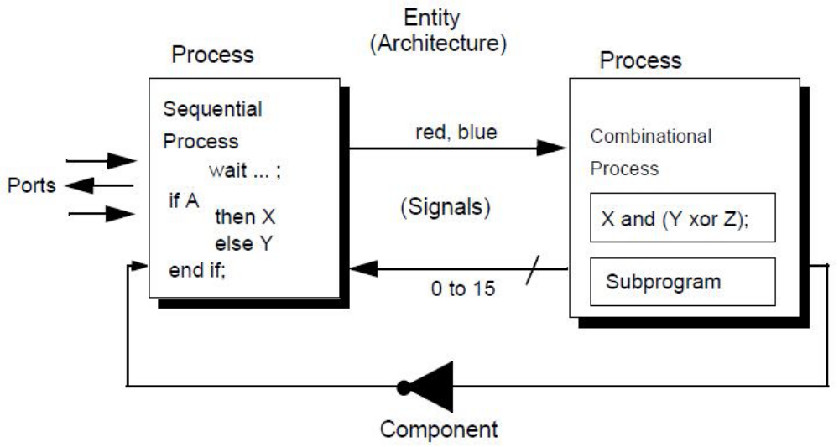
2.2.3 FPGA Study

Introduction

The Spartan®-3 family of Field-Programmable Gate Arrays is specifically designed to meet the needs of high volume, cost-sensitive consumer electronic applications. The eight-member family offers densities ranging from 50,000 to 5,000,000 system gates, as shown in Table 1.The Spartan-3 family builds on the success of the earlier Spartan-IIE family by increasing the amount of logic resources, the capacity of internal RAM, the total number of I/Os, and the overall level of performance as well as by improving clock management functions. Numerous enhancements derive from the Virtex®-II platform technology. Spartan-3 FPGA enhancements, combined with advanced process technology, deliver more functionality and bandwidth per dollar than was previously possible, setting new standards in the programmable logic industry.Because of their exceptionally low cost, Spartan-3 FPGAs are ideally suited to a wide range of consumer electronics applications, including broadband access, home networking, display/projection and digital television equipment.The Spartan-3 family is a superior alternative to mask programmed ASICs. FPGAs avoid the high initial cost, the lengthy development cycles, and the inherent inflexibility of conventional ASICs. Also, FPGA programmability permits design upgrades in the field with no hardware replacement necessary, an impossibility with ASICs [1].

Features
The Spartan FPGA-3 family has following features :
1. Low-cost, high-performance logic solution for high-volume,consumer-oriented
applications
2. Densities up to 74,880 logic cells
3. SelectIO™ interface signaling
4. Up to 633 I/O pins
5. 622+ Mb/s data transfer rate per I/O
6. 18 single-ended signal standards
7. 8 differential I/O standards including LVDS, RSDS
8. Termination by Digitally Controlled Impedance
9. Signal swing ranging from 1.14V to 3.465V
10. Double Data Rate (DDR) support
11. DDR, DDR2 SDRAM support up to 333 Mb/s
12. Logic resources
13. Abundant logic cells with shift register capability
14. Wide, fast multiplexers
15. Fast look-ahead carry logic
16. Dedicated 18 x 18 multipliers

Architectural Overview

The Spartan-3 family architecture consists of five fundamental programmable functional elements
Configurable Logic Blocks (CLBs) contain RAM-based Look-Up Tables (LUTs) to implement logic and storage elements that can be used as flip-flops or latches. CLBs can be programmed to perform a wide variety of logical functions as well as to store data. Input/Output Blocks (IOBs) control the flow of data between the I/O pins and the internal logic of the device. Each IOB supports bidirectional data flow plus 3-state operation. Twenty-six different signal standards, including eight high-performance differential standards, are available as shown in Table 2. Double Data-Rate (DDR) registers are included. The Digitally Controlled Impedance (DCI) feature provides automatic on-chip terminations, simplifying board designs.
1. Block RAM provides data storage in the form of 18-Kbit dual-port blocks.
2. Multiplier blocks accept two 18-bit binary numbers as inputs and calculate the product.
3. Digital Clock Manager (DCM) blocks provide self-calibrating, fully digital solutions for distributing, delaying, multiplying, dividing, and phase shifting clock signals. These elements are organized as shown in Figure 1. A ring of IOBs surrounds a regular array CLBs. The XC3S50 has a single column of block RAM embedded in the array. Those devices ranging from the XC3S200 to the XC3S2000 have two columns of block RAM. The XC3S4000 and XC3S5000 devices have four RAM columns. Each column is made up of several 18-Kbit RAM blocks; each block is associated with a dedicated multiplier.
CLB Overview

The Configurable Logic Blocks (CLBs) constitute the main logic resource for implementing synchronous as well as combinatorial circuits.Each CLB comprises four interconnected slices, as shown in Figure 11[33]. These slices are grouped in pairs. Each pair is organized as a column with an independent carry chain.The nomenclature that the FPGA Editor—part of the Xilinx development software—uses to designate slices is as follows: The letter ‘X’ followed by a number identifies columns of slices. The ‘X’ number counts up in sequence from the left side of the die to the right. The letter ‘Y’ followed by a number identifies the position of each slice in a pair as well as indicating the CLB row. The ‘Y’ number counts slices starting from the bottom of the die according to the sequence: 0, 1, 0, 1 (the first CLB row); 2, 3, 2, 3 (the second CLB row); etc. Figure 11 shows the CLB located in the lower left-hand corner of the die. Slices X0Y0 and X0Y1 make up the column-pair on the left where as slices X1Y0 and X1Y1 make up the column-pair on the right. For each CLB, the term “left-hand” (or SLICEM) indicates the pair of slices labeled with an even ‘X’ number, such as X0, and the term “right-hand” (or SLICEL) designates the pair of slices with an odd ‘X’ nu e.g., X1.mber
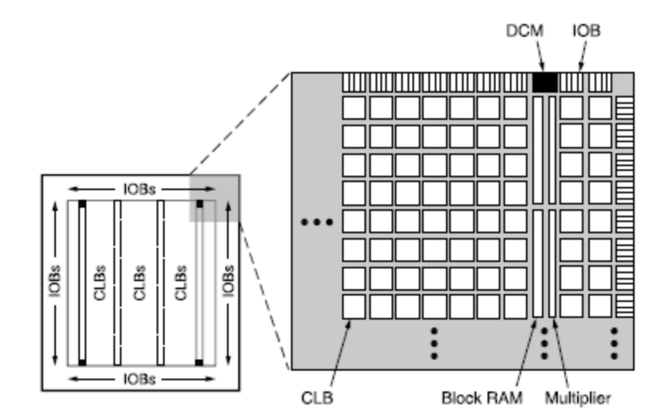,
Elements within a Slice

All four slices have the following elements in common: two logic function generators, two storage elements, wide-function multiplexers, carry logic, and arithmetic gates, as shown in Fig 2.8. Both the left-hand and right-hand slice pairs use these elements to provide logic, arithmetic, and ROM functions. Besides these, the left-hand pair supports two additional functions: storing data using Distributed RAM and shifting data with 16-bit registers. Fig is a diagram of the left-hand slice; therefore, it represents a superset of the elements and connections to be found in all slices.
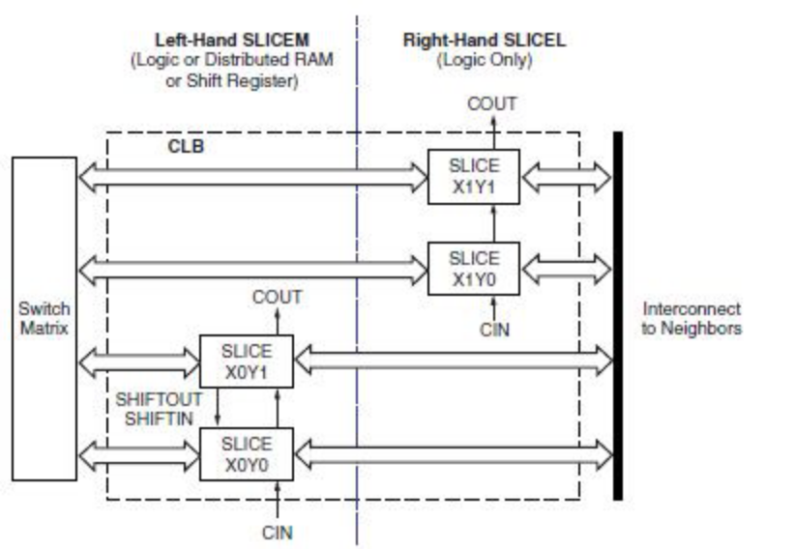
A Look-Up Table or LUT—is the main resource for implementing logic functions. Furthermore, the LUTs in each left-hand slice pair can be configured as Distributed RAM or a 16-bit shift register. For information on the former, refer to the chapter entitled Wide-function multiplexers effectively combine LUTs in order to permit more complex logic operations. Each slice has two of these multiplexers with F5MUX in the lower portion of the slice and FiMUX in the upper portion. Depending on the slice, FiMUX takes on the name F6MUX, F7MUX, or F8MUX. For more details on the multiplexers, refer to the chapter entitled “Using Dedicated Multiplexers” in UG331. The carry chain, together with various dedicated arithmetic logic gates, support fast and efficient implementations of math operations. The carry chain enters the slice as CIN and exits as COUT. Five multiplexers control the chain: CYINIT, CY0F, and CYMUXF in the lower portion as well as CY0G and CYMUXG in the upper portion. The dedicated arithmetic logic includes the exclusive-OR gates XORG and XORF (upper and lower portions of the slice, respectively) as well as the AND gates GAND and FAND (upper and lower portions, respectively).

IOB Overview

The Input/Output Block (IOB) provides a programmable, bidirectional interface between an I/O pin and the FPGA’s internal logic.A simplified diagram of the IOB’s internal structure appears in Fig [1]. There are three main signal paths within the IOB: the output path, input path, and 3-state path. Each path has its own pair of storage elements that can act as either registers or latches. The three main signal paths are as follows: The input path carries data from the pad, which is bonded to a package pin, through an optional programmable delay element directly to the I line. There are alternate routes through a pair of storage elements to the IQ1 and IQ2 lines.The IOB outputs I, IQ1, and IQ2 all lead to the FPGA’s internal logic. The delay element can be set to ensure a hold time of zero.
The 3-state path determines when the output driver is high impedance. The T1 and T2 lines carry data from the FPGA’s internal logic through a multiplexer to the output driver. In addition to this direct path, the multiplexer provides the option to insert a pair of storage elements. When the T1 or T2 lines are asserted High, the output driver is high impedance (floating, hi-Z). The output driver is active-Low enabled. All signal paths entering the IOB, including those associated with the storage elements, have an inverter option. Anyinverterplaced on these paths is automatically absorbed into the IOB.

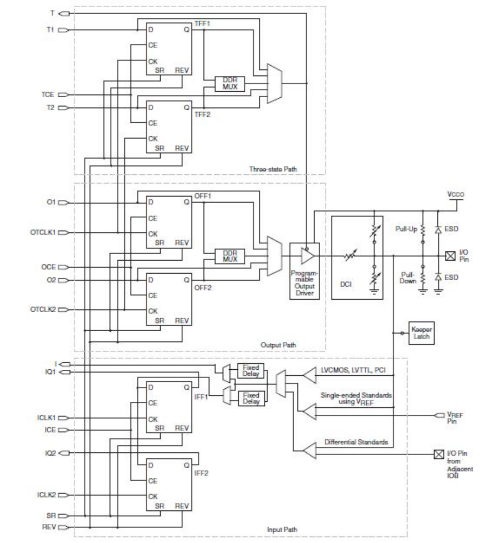
Fig2.9.Simplified IOB Diagram [1]

